**import** **numpy** **as** **np**

**import** **pandas** **as** **pd**

**import** **matplotlib.pyplot** **as** **plt**

**import** **seaborn** **as** **sns**

**import** **sklearn.datasets**

**from** **sklearn.model_selection** **import** train_test_split

**from** **xgboost** **import** XGBRegressor

**from** **sklearn** **import** metrics

In [6]:

house_price_dataset = sklearn.datasets.load_boston()

In [ ]:

print(house_price_dataset)

In [ ]:

house_price_df = pd.DataFrame(house_price_dataset.data)

print(house_price_df)

In [ ]:

house_price_df = pd.DataFrame(house_price_dataset.data, columns= house_price_dataset.feature_names)

print(house_price_df)

In [ ]:

house_price_df["Price"]= house_price_dataset.target

print(house_price_df)

In [20]:

correaltion = house_price_df.corr()

plt.figure(figsize=(10,10))

sns.heatmap(correaltion, cbar=**True**, square=**True**, annot=**True**, annot_kws={'size':10}, cmap="Greens")

Out[20]:

<AxesSubplot:>

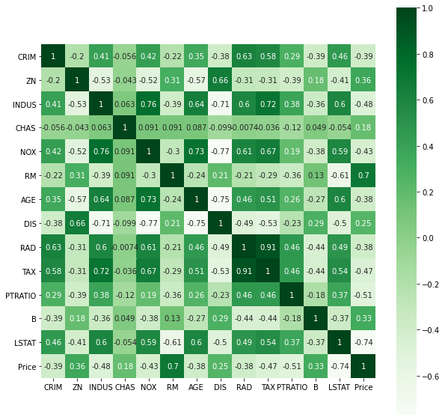

In [ ]:

In [14]:

x = house_price_df.drop(["Price"], axis=1)

y = house_price_df["Price"]

In [ ]:

print(x,y)

In [22]:

x_train,x_test,y_train,y_test = train_test_split(x,y,test_size=0.20, random_state=2)

print(x.shape,x_train.shape,x_test.shape, y_train.shape,y_test.shape)

(506, 13) (404, 13) (102, 13) (404,) (102,)

In [33]:

model1 = XGBRegressor()

In [36]:

model1.fit(x_train, y_train)

Out[36]:

XGBRegressor(base_score=0.5, booster='gbtree', colsample_bylevel=1,

colsample_bynode=1, colsample_bytree=1, gamma=0, gpu_id=-1,

importance_type='gain', interaction_constraints='',

learning_rate=0.300000012, max_delta_step=0, max_depth=6,

min_child_weight=1, missing=nan, monotone_constraints='()',

n_estimators=100, n_jobs=4, num_parallel_tree=1, random_state=0,

reg_alpha=0, reg_lambda=1, scale_pos_weight=1, subsample=1,

tree_method='exact', validate_parameters=1, verbosity=None)

In [ ]:

training_data_prediction = model1.predict(x_train)

print(training_data_prediction)

In [39]:

score_1 = metrics.r2_score(y_train, training_data_prediction)

score_2 = metrics.mean_absolute_error(y_train, training_data_prediction)

print(score_1,score_2)

0.9999948236320982 0.0145848437110976

In [ ]:

test_data_prediction = model1.predict(x_test)

print(test_data_prediction)

In [49]:

score_3 = metrics.r2_score(y_test, test_data_prediction)

score_4 = metrics.mean_absolute_error(y_test, test_data_prediction)

print(score_3,score_4)

0.8711660369151691 2.2834744154238233

In [53]:

plt.scatter(y_train, training_data_prediction)

plt.xlabel("actual size")

plt.ylabel("predicted Label")

plt.title("actual price vs predicted table")

plt.show()

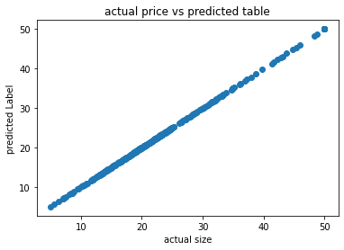

In [ ]: